How Workforce Planning Analytics Prevents Understaffing
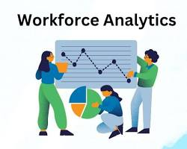

1. Demand Forecasting Based on Historical Data

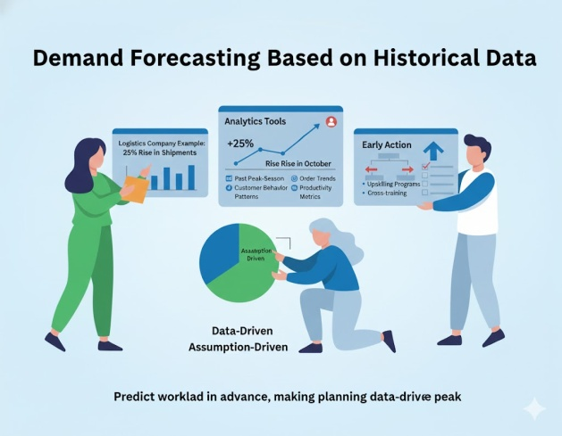
Analytics tools examine:
- Past peak-season volumes
- Order trends
- Customer behavior patterns
- Monthly and weekly productivity metrics
Using these insights, HR can predict workload well in advance, making manpower planning data-driven rather than assumption-driven.
Example:
A logistics company may predict a 25% rise in shipments in October based on last 3 years' data, helping managers schedule temporary and permanent staff accordingly.

2. Attrition & Absenteeism Prediction
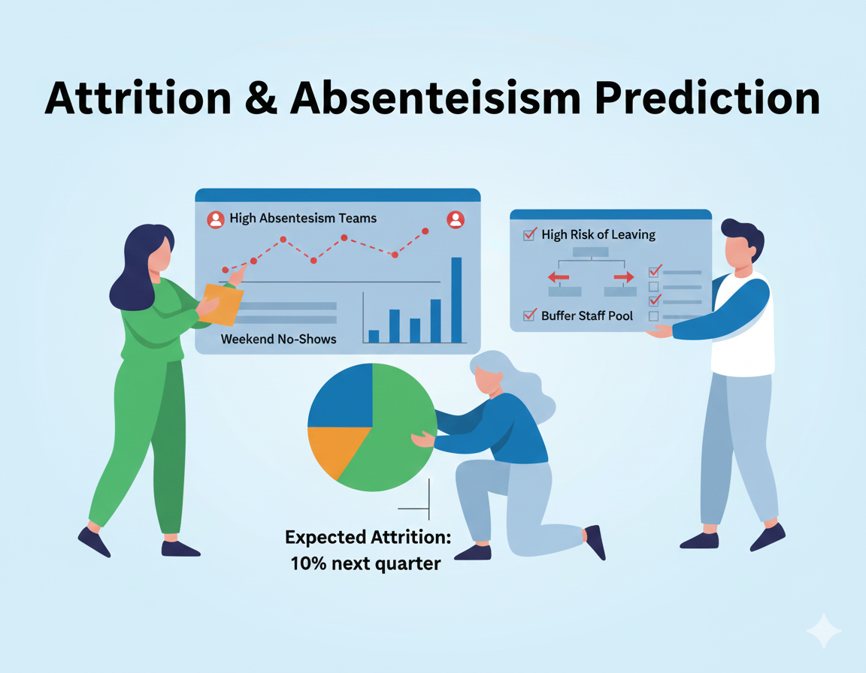

Machine learning models can predict:
- Who is at high risk of leaving
- Which teams typically face higher absenteeism
- Which weekends or festival days see the highest no-shows
By forecasting these patterns, HR can create buffer staff pools to avoid sudden shortages.

3. Skills & Role Gap Identification

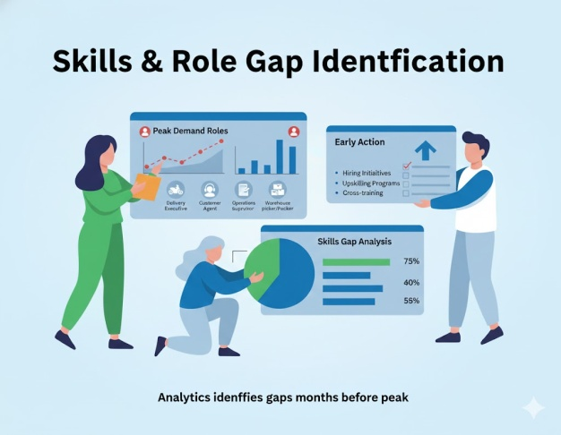
Peak loads often demand:
- More delivery executives
- More customer service agents
- More operations supervisors
- More warehouse pickers/packers
Workforce analytics identifies skill gaps early so hiring or upskilling can begin months before the peak.

4. Optimized Shift Scheduling

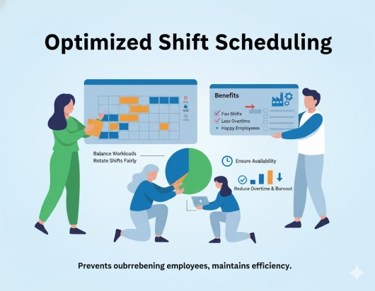
Analytics-driven scheduling tools help:
- Balance workloads
- Reduce overtime and burnout
- Rotate shifts fairly
- Ensure availability during busy hours
This prevents overburdening employees while maintaining operational efficiency.

5. Real-Time Manpower Monitoring

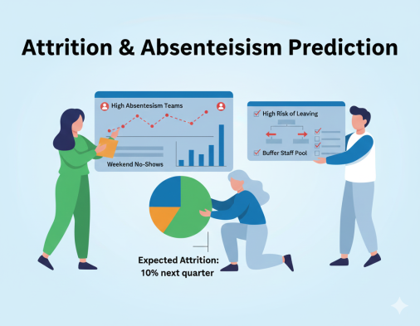
Dashboards give HR and managers live visibility of:
- Daily attendance
- Productivity output
- Headcount by shift
- Contractor vs employee ratio
- Pending shortages
Real-time insights allow immediate corrections before the gap becomes a crisis.

6. Scenario Planning (What-If Analysis)
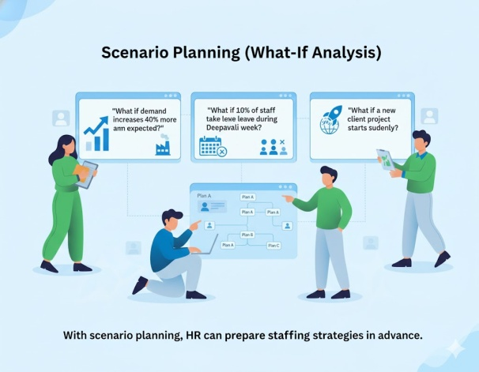
Workforce planning analytics can simulate:
- "What if demand increases 40% more than expected?"
- "What if 10% of staff take leave during Deepavali week?"
- "What if a new client project starts suddenly?"
With scenario planning, HR can prepare multiple staffing strategies in advance.
\

Benefits of Using Analytics for Peak Season Planning
- Zero or minimal understaffing incidents
- Higher customer satisfaction
- Reduced overtime and temporary hiring cost
- Better employee morale and reduced burnout
- Smooth business continuity
- Faster turnaround times and higher revenue

Conclusion
Peak season does not have to be chaotic.
With Workforce Planning Analytics, organizations can transform their HR function from reactive to predictive. By leveraging historical data, forecasting tools, and real-time dashboards, businesses ensure they are always prepared with the right manpower—even during the busiest months of the year.
Understaffing becomes a preventable issue rather than an unavoidable one.

